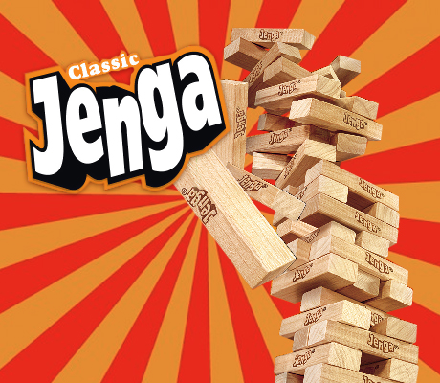**Crime and Punishment Jenga**

Build the Jenga tower.

Take it in turns to pull a brick from the tower.

When it is your turn, take a brick from within the tower (NOT the top layer) and find the number written on it. Define the word listed below against the number. The other players should check your definition.

If your definition is correct, return your brick to the top of the tower. Play then passes to the next person.

If the definition is incorrect, you must replace the brick on the top of the tower and then play again. The loser is the person who knocks the tower down.

|  |  |  |  |
| --- | --- | --- | --- |
| 1 | Addiction | 16 | Hate crime |
| 2 | Aims of punishment | 17 | Intention |
| 3 | Capital punishment | 18 | Law |
| 4 | Causes of crime | 19 | Mental illness |
| 5 | Community service | 20 | Murder |
| 6 | Conscience | 21 | Opposition to an unjust law |
| 7 | Contemporary British society | 22 | Principle of utility |
| 8 | Corporal punishment | 23 | Prison |
| 9 | Crime | 24 | Protection |
| 10 | Death penalty | 25 | Reformation |
| 11 | Deterrence | 26 | Retribution |
| 12 | Evil | 27 | Sanctity of life |
| 13 | Forgiveness | 28 | Theft |
| 14 | Good | 29 | Upbringing |
| 15 | Greed | 30 | Victim |

**Definitions: Crime and Punishment Keywords**

|  |  |  |
| --- | --- | --- |
| 1 | Addiction | A physical or mental dependency on a substance or activity. |
| 2 | Aims of punishment | Something that a punishment tries to achieve. |
| 3 | Capital punishment | Death penalty; state sanctioned execution. |
| 4 | Causes of crime | Things that can lead to crime being committed eg. poverty, upbringing, mental illness, addiction, greed, hate. |
| 5 | Community service | Punishment involving the criminal doing a set number of hours of unpaid work in the community. |
| 6 | Conscience | Sense of right and wrong; guilty voice in our head; seen as the voice of God by many religious believers. |
| 7 | Contemporary British society | English, Scottish and Welsh society in the present day. |
| 8 | Corporal punishment | Punishment in which physical pain is inflicted on the criminal. |
| 9 | Crime | An action which breaks the law; can be against the person, against property or against the state. |
| 10 | Death penalty | Capital punishment; state sanctioned execution. |
| 11 | Deterrence | An aim of punishment to put a person off committing a crime by the level of punishment inflicted on those who are found guilty. |
| 12 | Evil | Something or someone considered morally very wrong or wicked; often linked to the idea of a devil. |
| 13 | Forgiveness | Letting go of blame against a person for wrongs they have done. |
| 14 | Good | Often defined as the opposite of bad or the opposite of evil. |
| 15 | Greed | A reason for committing crime – selfishly wanting or desiring something or more of something. |
| 16 | Hate crime | A crime committed because of prejudice, eg race, religion, sexuality, disability or gender. |
| 17 | Intention | The plan that a person has before they act. |
| 18 | Law | The rules a country demands its citizens follow, the breaking of which leads to punishment. |
| 19 | Mental illness | A medical condition that affects a person’s emotions or moods. |
| 20 | Murder | Unlawfully killing another person. |
| 21 | Opposition to an unjust law | Crimes that are committed in protest about laws that exist that are considered either unfair or for the benefit of a select few. |
| 22 | Principle of utility | The idea that an action is right if it promotes the maximum happiness for the maximum number of people. |
| 23 | Prison | A secure building where criminals are locked up. |
| 24 | Protection | An aim of punishment; to keep people safe. |
| 25 | Reformation | An aim of punishment; helping the criminal see why their behaviour was wrong, so their mindset changes for the better. |
| 26 | Retribution | An aim of punishment; getting the criminal back for their crime. |
| 27 | Sanctity of life | The idea that life is sacred or special because it was created by God and loved by God, or because we are each unique. |
| 28 | Theft | Taking something without the owner’s consent. |
| 29 | Upbringing | The environment and culture in which children are raised. |
| 30 | Victim | Those who are directly affected by a crime. |