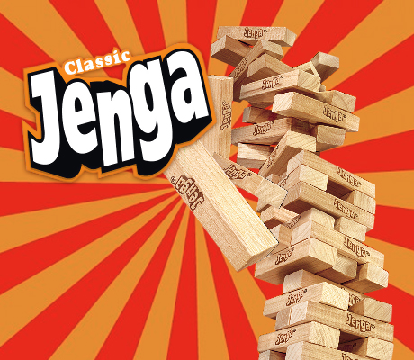**Revision Jenga**

Number your Jenga bricks 1-30.

Decide which topic you are going to use for your Jenga game. Identify either 15 or 30 words for the topic and write them in the table. If you use 15 words, they will be repeated for bricks 16-30.

Build the Jenga tower.

Take it in turns to pull a brick from the tower.

When it is your turn, take a brick from within the tower (NOT the top layer) and find the number written on it. Define the word listed below against the number. The other players should check your definition.

If your definition is correct, return your brick to the top of the tower. Play then passes to the next person.

If the definition is incorrect, you must replace the brick on the top of the tower and then play again. The loser is the person who knocks the tower down.

|  |  |  |  |
| --- | --- | --- | --- |
| 1 |  | 16 |  |
| 2 |  | 17 |  |
| 3 |  | 18 |  |
| 4 |  | 19 |  |
| 5 |  | 20 |  |
| 6 |  | 21 |  |
| 7 |  | 22 |  |
| 8 |  | 23 |  |
| 9 |  | 24 |  |
| 10 |  | 25 |  |
| 11 |  | 26 |  |
| 12 |  | 27 |  |
| 13 |  | 28 |  |
| 14 |  | 29 |  |
| 15 |  | 30 |  |